**:** **Nitte Meenakshi Institute of Technology**

(AN AUTONOMOUS INSTITUTION AFFILIATED TO VISVESVARAYA TECHNOLOGICAL UNIVERSITY, BELGAUM)

PB No. 6429, Yelahanka, Bangalore 560-064, Karnataka

Telephone: 080- 22167800, 22167860

Fax: 080 – 22167805



**OOPS COURSE MINI-PROJECT REPORT**

on

# *PROJECT TITLE :TRIANGLE OF HEALTH*

*Submitted in partial fulfilment of the requirement for the award of Degree of*

*Bachelor of Engineering*

*in*

## *Computer Science and Engineering*

Submitted by:

Student Name-1: T.THANMAI USN:1NT19CS203

Student Name-2:P.UDAYA SOWJANYA REDDY USN:1NT19CS13

Student Name-3 : Y.HIMAJA USN:1NT19CS219

**Department of Computer Science and Engineering**

### ( NBA Accredited till 2020)

2020-2021

 **Nitte Meenakshi Institute of Technology**

( AN AUTONOMOUS INSTITUTION AFFILIATED TO VISVESVARAYA TECHNOLOGICAL UNIVERSITY, BELGAUM)

PB No. 6429, Yelahanka, Bangalore 560-064, Karnataka

Telephone: 080- 22167800, 22167860

Fax: 080 - 22167805

# DEPARTMENT OF COMPUTER SCIENCE AND ENGINEERING

**CERTIFICATE**

This is to certify that the Course Project titled “*TRIANGLE OF HEALTH*”is an authentic work carried out by **(THANMAI-1NT19CS203,UDAYA-1NT19CS136,HIMAJA-1NT19CS219)** bonafide students of **Nitte Meenakshi Institute of Technology**, Bangalore in partial fulfilment for the award of the degree of ***Bachelor of Engineering*** in COMPUTER SCIENCE AND ENGINEERING of Visvesvaraya Technological University, Belagavi during the academic year ***2019-2020.***

**Signature of the Faculty Incharge Name and Signature of the**

**HOD**

**(Vinay T R)**

**Dr.Thippeswamy M.N**

**DECLARATION**

We hereby declare that

(i)This presentation does not contain text, graphics or tables copied and pasted from the Internet, unless specifically acknowledged and the source being detailed in the report and in the reference’s sections.

(ii)All corrections and suggestions indicated during the interval presentation have been incorporated in the report.

(iii)Content of the report has been checked for the plagiarism requirement .

## ACKNOWLEDGEMENT

The satisfaction and euphoria that accompany the successful completion of any task would be incomplete without the mention of the people who made it possible, whose constant guidance and encouragement crowned our effort with success. We express our sincere gratitude to our Principal **Dr. H. C. Nagaraj**, Nitte Meenakshi Institute of Technology for providing facilities.

We wish to thank our HoD**, Dr.Thippeswamy M.N** for the excellent environment created to further educational growth in our college. We also thank him for the invaluable guidance provided which has helped in the creation of a better technical report.

Thanks to our Subject Faculty **Mr. Vinay T R** for guiding and helping us out in the successful completion of this presentation.

Signature

|  |  |
| --- | --- |
| Student Name-1 | USN |
| T.THANMAI | 1NT19CS203 |
| P.UDAYA SOWJANYA REDDY | 1NT19CS136 |
| Y.HIMAJA | 1NT19CS219 |

Date : 12-01-2021

**ABSTRACT**

Physical health and wellness is a critical issue gaining internationally attention because of the lockdown for so many months. Highlighting a need for more effective efforts to

promote health and well-being of the person health. This report

will provide an overview of triangle of health, discussing that health is not only about physical fitness but also include mental and social health.

Updated core competencies calling for a balanced approach to health,

including focus on nutrition, exercise, mindfulness, effective stress management and social skills. programs designed to promote physician health and wellness .

There are three key aspects of your personal health, and here is how I define them:

Physical: Having a strong, functional, and energetic body; an absence of sickness, disease, and pain.

Mental: Psychological and emotional wellness; a lack of pronounced or debilitating anxiety, depression, grief, relationship problems, and addictions.

Social: An overriding sense of meaning and purpose in life, and, for some, a belief in a higher power; an absence of existential loneliness, despair, and hopelessness.

All three areas of your health are, of course, quite important. If your physical health slips too far, then you’re incapacitated, or worse yet, dead! If your mental health is diminished enough, you can’t adequately function and handle your responsibilities. However, I believe your spiritual wellness is by far the most important aspect of your health, and I’ll explain why.

First, let me give an example from my own life. There was a time when I was physically healthy and mentally well-adjusted, and yet a lack of spiritual health brought everything crashing down. I have discussed this in other posts, when early in my retirement I lost a sense of purpose in my life. This lack of spiritual wellness caused a sharp downturn in the rest of my health and well-being. I became terribly depressed, and developed a host of physical problems, such as headaches and extreme lethargy. A major problem with my spiritual health dramatically impacted all areas of my health and made me extremely sick.I have since gained a renewed sense of meaning in my life by determining that my purpose is to be of service to others. And while a lack of spiritual meaning quickly dragged me down, the revival in my spiritual life had the opposite effect, rapidly lifting me back up. The best analogies I can think of is that it is as though spiritual wellness provides a shield or defense—or buoyancy—in one’s life. A rising tide lifts all boats! My sense of purpose and positive outlook made me less susceptible to physical ailments and disease, and when I do have a physical problem, it doesn’t seem to impact me as much. My attitude is that I have too many important things to do to dwell on it! And I also seem immunized from the mental problems I’ve suffered from so greatly in the past. Now, when I begin to feel anxious, I say to myself, “I don’t care about that. If I have some anxiety, it’s okay, God will take care of me. He won’t let me fall too far. I’m just not worried about it anymore.” And what happens? My anxiety never really takes hold, and dissipates.

But don’t just take it from me. Christopher Reeve, the famous actor, became a quadriplegic after suffering a devastating spine injury, and yet the strong sense of purpose he adopted after his tragic accident propelled him to do great things. Also, I just finished reading a book titled “An Unquiet Mind,” an autobiography by a woman who has severe bipolar disorder, but has managed to lead an exemplary life. She earned a doctorate degree, was named a professor of psychiatry at Johns Hopkins Medical School, and made it her life’s work to help other people who suffer from bipolar disorder. Both of these people called on a strong sense of spirituality and purpose to pull themselves up from the potential despair of devastating illnesses, resulting in them living highly energetic and useful lives.

You might consider thinking more about your special purpose here on earth, as a way to improve your overall health and the quality of your life. This can be achieved by finding some aspect of your existence that you choose to be even more committed to, like family, work, or some other useful purpose, and by believing in a higher power that cares deeply about you and won’t let you slip or fall. It might be just the thing to get you soaring through life!

## 

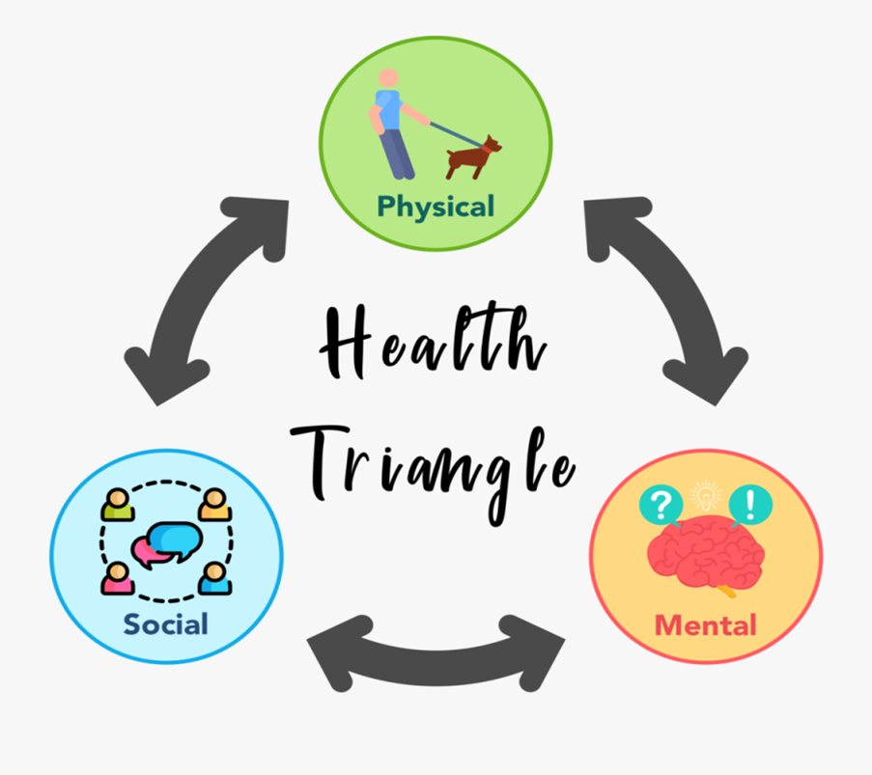

**TABLE OF CONTENTS**

**Page Nos.**

**CHAPTER 1: INTRODUCTION-------------------------------------------------x**

* 1. Need of knowing personal health---------------------------------------------------------------x
  2. Motivation--------------------------------------------------------------------------------x
  3. Objectives-------------------------------------------------------------------------------- x

**CHAPTER 2: OVERVIEW OF THE PROJECT---------------------------------x**

* 1. Triangle of the health--------------------------------------------------------------------------x
  2. FILE ATTACHED---------------------------------------------------------------------------------x

**CHAPTER 3: DESIGN AND IMPLEMENTATION----------------------------x**

* 1. Flow diagram of the project----------------------------------------------------------x
  2. Algorithm----------------------------------------------------------------------------------x
  3. Snapshots----------------------------------------------------------------------------------x

3.4 OUTPUT------------------------------------------------------------------------------------X

**CHAPTER 4: CONCLUSION AND APPLICATIONS-----------------------x**

* 1. Conclusion------------------------------------------------------------------------------x
  2. Applications---------------------------------------------------------------------------x

**CHAPTER 5: REFERENCES------------------------------------------------------x**

INTRODUCTION

**1.1::::NEED TO KNOW ABOUT YOUR HEALTH:**

To put it simply, physical activity and exercise is important for everyone. Children, adolescents, and adults of all ages need regular physical activity. Physical activity promotes good health, and you should stay active throughout all stages of your life regardless of your body type or BMI.

Understanding the benefits of physical fitness and knowing how active you should be can help you maintain good health and improve your overall quality of life. Here are a few benefits of regular physical activity that demonstrate the importance of physical fitness

Regular exercise and physical activity increase muscle strength, bone density, flexibility, and stability. Physical fitness can reduce your risk for and resilience to accidental injuries, especially as you get older. For example, stronger muscles and better balance mean that you’re less likely to slip and fall, and stronger bones mean that your less likely to suffer bone injuries should you take a tumble.

A sedentary lifestyle and a lack of physical activity can take a toll on a person’s body. Physical inactivity is associated with an increased risk for certain types of cancer, numerous chronic diseases, and mental health issues. Exercise, however, has been shown to improve mood and mental health, and provides numerous health benefits. Of course physical fitness also allows you to do things that you may not otherwise be able to do.

Staying active and healthy allows you to do activities that require a certain level of physical fitness. For example, hiking to the top of a mountain is a rewarding experience that instills a sense of accomplishment and provides spectacular scenery, but there are people who cannot experience this due to fitness

**1.2:::MOTIVATION**

In this covid 19 pandemic which has lead to everyone became much concerned about their health.By considering this we came to one conclusion that health does not only include physical fitness but also mental and social. So we came up with the ideas to write the code on it .

**“To keep the body in good health is a duty… otherwise we shall not be able to keep the mind strong & clear.”- Buddha**

Instead, focus on being healthy from the inside out," Magee says. "Eat well, and exercise regularly. And remember that you can be sexy and look and feel fabulous and not be thin

Feel Good About Yourself Today.

We all need a cheering section -- having to account to someone else gives you a reason to hang in there when you can't muster determination from within. It doesn't matter where the support comes from -- a spouse, friend, co-worker, or online "buddy," or others.

Think of five people who might be in your cheering section. Talk to these people about giving you support and holding you accountable as you work to reach your weight loss or health goals. Call upon your cheering section when you're having trouble sticking with good health habits. When you do reach small weight loss or exercise goals.

**1.3:::OBJECTIVES**

Our main objective is to make people know that mental health and social health are as important as physical health.

Not only us but everyone think that health is only physical fitness and muscles but its about our

Mental health includes our emotional, psychological, and social well-being. It affects how we think, feel, and act. It also helps determine how we handle stress, relate to others, and make choices. Mental health is important at every stage of life, from childhood and adolescence through adulthood.

Over the course of your life, if you experience mental health problems, your thinking, mood, and behavior could be affected. Many factors contribute to mental health problems, including:

Biological factors, such as genes or brain chemistry

Life experiences, such as trauma or abuse

Family history of mental health problems

Mental health problems are common but help is available. People with mental health problems can get better and many recover completely.

People are social creatures who are mutually dependent, relying on others for our well-being, just as they rely on us. To be well people need to love and be loved. We have the need to belong and to be connected.

It is statistically proven that people with good social connections tend to be healthier and live longer than those who don’t.

Ongoing stress also precipitates the development of more serious mental health issues such as anxiety and depression

Aside from impairing overall health and well-being, depression and anxiety symptoms can further adversely affect academic achievement.

**CHAPTER 2:**

**OVERVIEW OF THE PROJECT-**

**2.1Triangle of the health---**

Overall health wellness promotes proper care of our bodies for optimal health and functioning. There are many elements of physical wellness that all must be cared for together. Overall wellness encourages the balance of physical activity, nutrition and mental well-being to keep your body in top condition

Health classifications:

1. Physical Health

2. Mental Health

3. Social Health

**Sub classifications :**

* 1) **Physical Health**: The physical health can be measured in terms of BMI(Body Mass Index). Height and weight for each student were measured based on the protocol of National Health and Nutrition Examination Survey. The BMI was calculated according the following formula: BMI = Weight (kg) / height (m)2. BMI values were generally divided into three groups based on the criteria of World Health Organization (WHO): < 18.5 kg/m2, 18.5 to 25 kg/m2 and above 25 kg/ m2 which represented low weight, normal weight, overweight and obesity, respectively.
* 2) **Mental Health:**  It affects how we think, feel, and act. It also helps determine how we handle stress, relate to others, and make choices. **It** is important at every stage of life, from childhood and adolescence through adulthood. Here we measure Mental health in terms of Mental age. Mental age can be calculated by multiplying IQ and present age.
* 3) **Social Health: Social health** can be defined as our ability to interact and form meaningful relationships with others. It also relates to how comfortably we can adapt in **social** situations.
* Over the years, sociologists have created a link between social relationships and health outcomes. Studies are showing that social relationships both quality and quantity are having short and long-term effect on our health. Here we measure Social Health by a quiz for which you give a rating from 1 to 10.
  1. **FILE ATTACHED:**

***1. You often spend time exploring unrealistic yet intriguing ideas? Rate your answer.***

***2. People can rerely upset you. Rate your answer.***

***3. You are very affectionate with people you care about. Rate your answer.***

***4. You rarely worry if you made a good impression on someone you met. Rate your answer.***

***5. You are still bothered by the mistakes you made a long time ago. Rate your answer.***

***6. You have a careful & methodical approach to life. Rate your answer.***

***7. At parties & similar events you can mostly be found farther away from the action. Rate your answer.***

***8. You can stay calm under a lot of pressure. Rate your answer.***

***9. You often find it difficult to relate to people who let their emotions guide them. Rate your answer.***

***10. In your opinion, it is sometimes OK to step on others to get ahead in life. Rate your answer.***

**CHAPTER 3:**

**DESIGN AND IMPLEMENTATION**

* 1. **Flow diagram of the project**

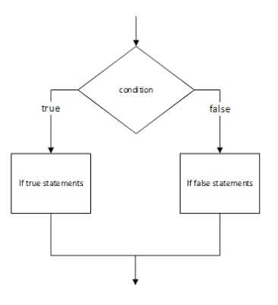

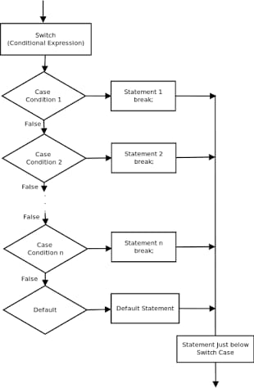

* 1. **Algorithm**

**Social health:**

1.Measure the social health using files

2.Give file input

3.Rate your answers from 1 to 10 for the given file input (questions)

4.The sum of answers(rated from 1 to 10) is calculated

5.Average of the sum is calculated

6.According to the value of average, output is displayed.

* ***Physical Health:***
* A person’s BMI is calculated with the following formula:
* BMI = weight /height^2
* where weight is measured in kilograms(kg) and height is measured in meters(m).
* A sedentary person’s weight is considered to be optimal if his or her BMI is between 18.5 and 25. If the BMI is less than 18.5, the person is considered to be underweight. If the BMI value is greater than 25, the person is considered to be overweight
* A message indicating whether the person has optimal weight, is underweight, or is overweight is displayed.
* **Mental Health:**
* A person mental age is calculated by using following formula:
* Mental age=(IQ*presentage)/100
* To know the IQ solve the question given using switch case
* IQ value is given according to answer and input that to IQ
* Where the IQ and Present age are taken as input

After calculating, the Mental age is displayed

* 1. **SNAPSHOT**

**PROGRAM** **CODE::**

#include<iostream>

#include<fstream>

using namespace std;

class details{

private:char name[100];

char gender[100];

public:void read()

{

cout<<"enter name and gender \n";

cin>>name>>gender;

}

void display()

{

cout<<"name:\t \n"<<name<<"\ngender:\t \n"<<gender<<endl;

}

};

int main()

{

details obj;

obj.read();

obj.display();

ifstream in;

string str1;

string str2;

string str3;

string str4;

string str5;

string str6;

string str7;

string str8;

string str9;

string str10;

in.open("social.txt");

if(!in)

{

cout<<"file does not exist \n";

return 1;

}

getline(in,str1);

getline(in,str2);

getline(in,str3);

getline(in,str4);

getline(in,str5);

getline(in,str6);

getline(in,str7);

getline(in,str8);

getline(in,str9);

getline(in,str10);

cout<<str1<<"\n"<<str2<<"\n"<<str3<<"\n"<<str4<<"\n"<<str5<<"\n"<<str6<<"\n"<<str7<<"\n"<<str8<<"\n"<<str9<<"\n"<<str10<<endl;

in.close();

int A,B,C,D,E,F,G,H,I,J;

int sum;

printf("rate yourself 1 to 10 for the bove 10 questions \n");

cin>>A>>B>>C>>D>>E>>F>>G>>H>>I>>J;

sum=(A+B+C+D+E+F+G+H+I+J)/10;

if(sum<=10 &&sum>=1)

{

if(sum<=7)

{

cout<<"\nyou are not socially associated with people well ........!!!!!!try to improve your skills ........!!!\n";

}

else if(sum>=7)

{

cout<<"\nyou are socially associated with people well..........!!!keep rocking......!!!\n";

}

}

else

{

cout<<"invalid input \n";

}

cout<<" \nweight in kg : ";

double weight;

cin>>weight;

cout<<"\nheight in meters : ";

double height;

cin>>height;

double BMI=weight/(height*height);

cout<<"BMI is :\n"<<BMI;

if(BMI<18.5)

cout<<"\n you are underweight !!..........try to improve \n";

if(BMI>=18.5&& BMI<=25)

cout<<" \nyou are physically fit.....good work.....!!";

if(BMI>25)

cout<<"\nyou are overweight....!!.....try to loose ";

int mentalage;

int presentage;

int IQ;

int T,U,V,W,X;

char ans;

int value;

T=0;

U=0;

V=0;

W=0;

X=0;

cout << "\n Welcome to the IQ Test!! \n";

cout << "There are five questions to solve: \n" << endl;

cout<<"question 1:\n";

cout<<"Which number should come next in the series? 1 ,1,2,3,5, \n" <<endl;

      cout << "A. 8 B. 21" << endl;

      cout << "C. 26 D. 13"<<endl;

      cin >> ans;

switch (ans)

      {

      case 'A' :

        cout << " Wrong answer!\n";

        break;

      case 'B' :

       cout << " Wrong answer!\n";

          break;

      case 'C' :

        cout << " Wrong answer!\n";

          break;

      default:

        cout <<" You got the correct answer!\n";

T=1;

      }

cout << "Question no. 2:" << endl;

      cout << "Of these four elements, which one is the appropriate element of Sodium?";

      cout << "A. Sb B. Si" << endl;

      cout << "C. Na D. Sm";

      cin >> ans;

      switch (ans)

      {

      case 'A' :

        cout << " Wrong answer!";

        break;

      case 'B' :

       cout << " Wrong answer!";

        break;

      case 'D' :

        cout << " Wrong answer!";

        break;

      default:

        cout <<" You got the correct answer!";

U=1;

      }

cout << "Question no. 3:" << endl;

      cout << "Choose the appropriate options to complete the sentences." << endl;

      cout << "Most of the patient visits ---- to physician assistants in the recent years all around he world";

      cout << "A. have been made B. will have been made" << endl;

      cout << "C. make D. have made";

      cin >> ans;

      switch (ans)

      {

      case 'B' :

        cout << "Wrong answer!";

        break;

      case 'C' :

       cout << "Wrong answer!";

        break;

      case 'D' :

        cout << "Wrong answer!";

break;

      default:

        cout <<" You got the correct answer!";

V=1;

      }

cout << "Question 4:" << endl;

      cout << "K is the chemical symbol for which element?" << endl;

      cout << "A. Magnesium B. Potassium" << endl;

      cout << "C. Mercury D. Oxygen";

      cin >> ans;

      switch (ans)

      {

      case 'A' :

        cout << " Wrong answer!";

        break;

      case 'C' :

       cout << " Wrong answer!";

        break;

      case 'D' :cout << " Wrong answer!";

        break;

      default:

        cout <<" You got the correct answer!";

W=1;

      }

cout << "Question 5:" << endl;

      cout << "Which of the following is used in pencils?" << endl;

      cout << "A. Graphite B. Silicon" << endl;

      cout << "C. Charcoal D. Phosporous";

      cin >> ans;

      switch (ans)

      {

      case 'B' :

        cout << " Wrong answer!";

        break;

      case 'C' :

       cout << " Wrong answer!";

        break;

      case 'D' :

        cout << " Wrong answer!";

        break;

      default:

        cout <<" You got the correct answer!";

X=1;

      }

value=T+U+V+W+X;

if(value<=1)

cout<<"your iq is below average that is approx :70"<<endl;

if(value<=2)

cout<<"your iq is average that is approx:110"<<endl;

if(value>=3)

cout<<"your iq is high that is approx :140"<<endl;

cout<<"\nenter IQ : \n";

cin>>IQ;

cout<<"\nenter ur present age : ";

cin>>presentage;

mentalage=(IQ*presentage)/100;

cout<<"your mental age is :"<<mentalage;

return 0;

}

**OUTPUT::**

**enter name and gender**

**thanmai**

**female**

**name:**

**thanmai**

**gender:**

**female**

**1. You often spend time exploring unrealistic yet intriguing ideas? Rate your answer.**

**2. People can rerely upset you. Rate your answer.**

**3. You are very affectionate with people you care about. Rate your answer.**

**4. You rarely worry if you made a good impression on someone you met. Rate your answer.**

**5. You are still bothered by the mistakes you made a long time ago. Rate your answer.**

**6. You have a careful & methodical approach to life. Rate your answer.**

**7. At parties & similar events you can mostly be found farther away from the action. Rate your answer.**

**8. You can stay calm under a lot of pressure. Rate your answer.**

**9. You often find it difficult to relate to people who let their emotions guide them. Rate your answer.**

** clang++-7 -pthread -std=c++17 -o main main.cpp**

** ./main**

**enter name and gender**

**thanmai**

**female**

**name:**

**thanmai**

**gender:**

**female**

**1. You often spend time exploring unrealistic yet intriguing ideas? Rate your answer.**

**2. People can rerely upset you. Rate your answer.**

**3. You are very affectionate with people you care about. Rate your answer.**

**4. You rarely worry if you made a good impression on someone you met. Rate your answer.**

**5. You are still bothered by the mistakes you made a long time ago. Rate your answer.**

**6. You have a careful & methodical approach to life. Rate your answer.**

**7. At parties & similar events you can mostly be found farther away from the action. Rate your answer.**

**8. You can stay calm under a lot of pressure. Rate your answer.**

**9. You often find it difficult to relate to people who let their emotions guide them. Rate your answer.**

**10. In your opinion, it is sometimes OK to step on others to get ahead in life. Rate your answer.**

**rate yourself 1 to 10 for the bove 10 questions**

**8**

**5**

**7**

**6**

**8**

**7**

**8**

**6**

**7**

**8**

**you are not socially associated with people well ........!!!!!!try to improve your skills ........!!!**

**weight in kg : 58**

**height in meters : 1.6**

**BMI is :**

**22.6562**

**you are physically fit.....good work.....!!**

**Welcome to the IQ Test!!**

**There are five questions to solve:**

**question 1:**

**Which number should come next in the series? 1 ,1,2,3,5,**

**A. 8 B. 21**

**C. 26 D. 13**

**a**

**You got the correct answer!**

**Question no. 2:**

**Of these four elements, which one is the appropriate element of Sodium?A. Sb B. Si**

**C. Na D. Sma**

**You got the correct answer!Question no. 3:**

**Choose the appropriate options to complete the sentences.**

**Most of the patient visits ---- to physician assistants in the recent years all around he worldA. have been made B. will have been made**

**C. make D. have madea**

**You got the correct answer!Question 4:**

**K is the chemical symbol for which element?**

**A. Magnesium B. Potassium**

**C. Mercury D. Oxygena**

**You got the correct answer!Question 5:**

**Which of the following is used in pencils?**

**A. Graphite B. Silicon**

**C. Charcoal D. Phosporousa**

**You got the correct answer!your iq is high that is approx :140**

**enter IQ :**

**140**

**enter ur present age : 18**

**your mental age is :25**

**CHAPTER 4:**

**CONCLUSION AND APPLICATIONS**

* 1. **Conclusion**

If you do maintain a healthy lifestyle, there are many benefits, and not only for your body. Some are maintaining a healthy weight, reducing risk of developing heart disease, increasing energy levels, assisting a healthy immune system, and it helps you to be more social. Having a healthy lifestyle is crucial for giving your body everything that it needs.

1.Reduces the risk of diseases like diabetes, obesity, etc.

2. Helps in healing the injuries quickly.

3. Increases the lifespan of the person.

4. Decreases stress and anxiety.

With daily exercise and proper diet, a person can achieve good health and fitness. It not only makes the person happy but also makes him/her free of stress and worries.

For many people, knowing the status of their health only becomes important when they begin to lose it. And while the advice of medical professionals and organizations may differ on how frequently you should get a thorough medical checkup, the consensus is clear that it’s a must to pay your doctor a visit even before a serious health condition arises.

Aside from getting ahead of any potential conditions, knowing the status of your health can also be beneficial to other aspects of your life such as your finances, your future plans, and also your retirement. Schedule an appointment with your doctor or clinic and begin to reap the rewards of knowing your health.

* 1. **Applications**

If you do maintain a healthy lifestyle, there are many benefits, and not only for your body. Some are maintaining a healthy weight, reducing risk of developing heart disease, increasing energy levels, assisting a healthy immune system, and it helps you to be more social. Having a healthy lifestyle is crucial for giving your body everything that it needs.

1.Reduces the risk of diseases like diabetes, obesity, etc.

2. Helps in healing the injuries quickly.

3. Increases the lifespan of the person.

4. Decreases stress and anxiety.

10. With daily exercise and proper diet, a person can achieve good health and fitness. It not only makes the person happy but also makes him/her free of stress and worries**.**

**CHAPTER 5: REFERENCES**

**Reference sources:**

**Geeksforgeeks**

**Github**

**Codesource**

**Reference links:**

[**https://stackoverflow.com/questions/20739453/using-getline-with-file-input-in-c**](https://stackoverflow.com/questions/20739453/using-getline-with-file-input-in-c) [**https://www.tutorialspoint.com/cplusplus/cpp_files_streams.htm**](https://www.tutorialspoint.com/cplusplus/cpp_files_streams.htm)

[**https://www.google.com/search?q=mental+age+related+to+iq&oq=mental+age+related+to+iq&aqs=chrome**](https://www.google.com/search?q=mental+age+related+to+iq&oq=mental+age+related+to+iq&aqs=chrome)**.**

[**http://www.cplusplus.com/forum/beginner/214052/**](http://www.cplusplus.com/forum/beginner/214052/)